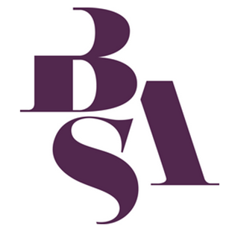
British Sociological Association
Sociology of Religion Study Group
Peter B. Clarke Memorial Prize
Postgraduate Essay Competition 2018

Name

Address

Phone number

Email Address

University/Institution

Programme of Study currently enrolled on

Title of Essay

Word Count (including footnotes but excluding bibliography)

Study Group Member (you must become a member of the study group to enter the competition) | Existing member?  or  Recently joined?  (please tick)

Essays should be submitted as a single MS Word document (including this cover sheet) as an attachment to Dr Michael Munnik (munnikm@cardiff.ac.uk)

The closing date for submission is the 31st January 2018.

